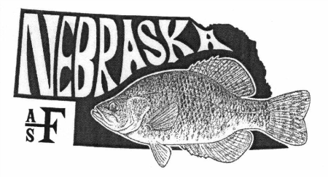
Nebraska Chapter of the American Fisheries Society
53rd Annual Meeting
January 19-20, 2022
Ramada Midtown Conference Center
2503 S. Locust
Grand Island, NE 68801
Event Time
January 19, 2022
Breakfast on your own (Continental Breakfast provided at Hotel) 6:30-8:00
Registration 7:30-9:00
Welcome/Housekeeping 9:00-9:10
Presentations 9:10-10:25
Break 10:25-10:45
Presentations 10:45-12:00
Lunch (provided) 12:00-1:20
Presentations 1:20-3:00
Break 3:00-3:30
Business Meeting 3:30-5:00
Social/Poster Session 5:00-6:00
Dinner (provided) 6:00-7:30
Social cont’d/Auction/Raffle 7:30-10:30
January 20, 2022
Breakfast on your own (Continental Breakfast provided at Hotel) 6:30-8:30
Presentations 8:30-10:10
Break 10:10-10:30
Presentations 10:30-11:45
Adjourn (Lunch on your own)

